***My Virtual Desktop***

***Desktopnc.niagaracollege.ca***

***This Pamphlet Online***

[*https://its.niagaracollege.ca/*](https://its.niagaracollege.ca/)

***School Computer***

**Don’t let the change of home screen scare you.**

**As Wikipedia says:**

In computing, a virtual machine (VM) is an emulation of a computer system. Virtual machines are based on computer architectures and provide functionality of a physical computer. Their implementations may involve specialized hardware, software, or a combination.

**To learn more visit:**

[**https://en.wikipedia.org/wiki/Virtual_machine**](https://en.wikipedia.org/wiki/Virtual_machine)

1. Turn on the computer

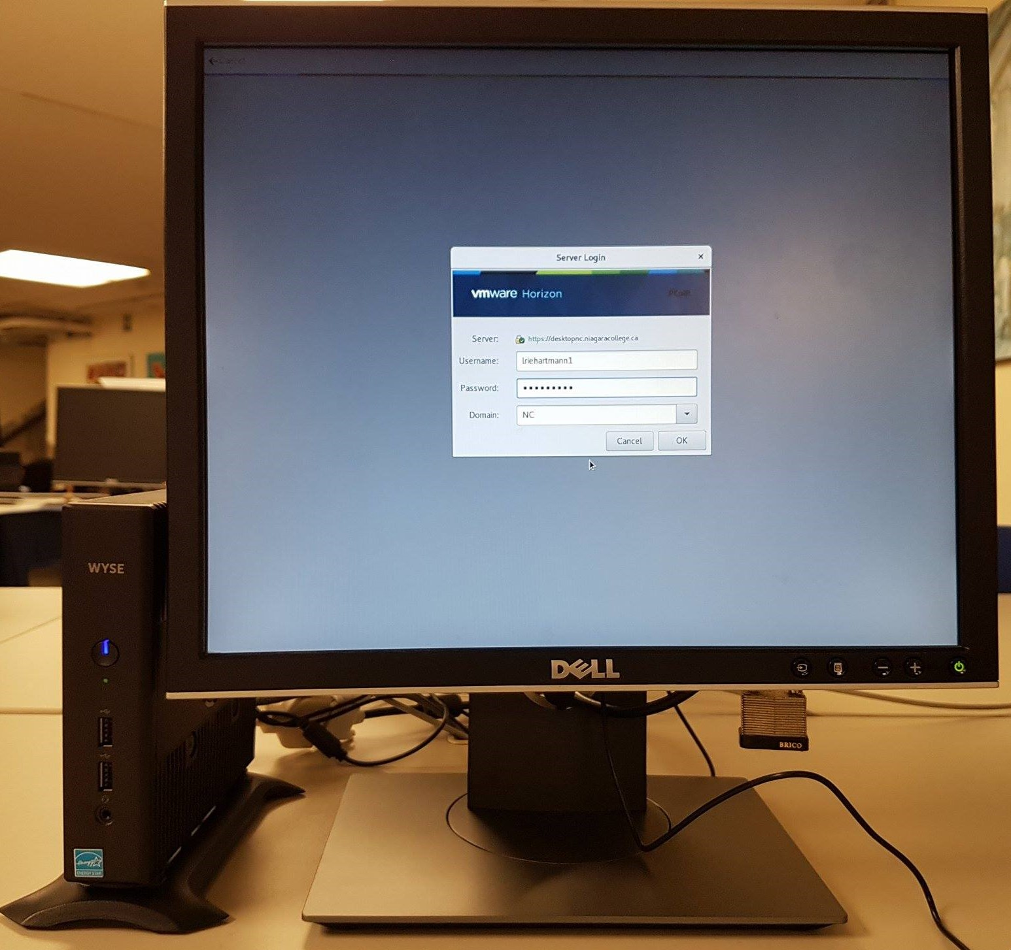

1. Log in with:
   * **Blackboard Username**
   * **Blackboard Password**
2. To Log off:

Click **Start**, **Power** then **Shut Down**

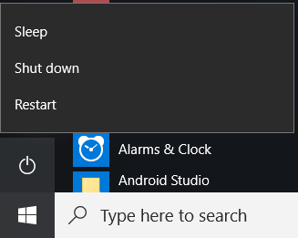

**Remember that you cannot save anything to this system! Save it online or on a USB stick**

**How to Guides on the following topics:**

Blackboard

Windows 10

Office 365

OneDrive

Skype for Business

<https://its.niagaracollege.ca/>

**Remember that you cannot save anything to this system! Save it online or on a USB stick**

1.

**Niagara College Help Desk**

Monday-Thursday 8:30am to 10:00pm

Friday 8:30am to 4:30pm

Phone: 905-735-2211 ext. 7642

<https://its.niagaracollege.ca/>

***My Virtual Desktop***

**Desktopnc.niagaracollege.ca**

**Contents**

* Connect through your web browser
* Download the VMWare client to work from home
  + Download for MAC
  + Download for Windows
* Benefits

**Desktopnc.niagaracollege.ca**



**Niagara College Help Desk**

Monday-Thursday 8:30am to 10:00pm

Friday 8:30am to 4:30pm

Phone: 905-735-2211 ext. 7642

<https://its.niagaracollege.ca/>

***Download the App***

# Access My Virtual Desktop from home

1. Open your **Web browser** of Choice
2. Navigate to:[**https://desktopnc.niagaracollege.ca**](https://desktopnc.niagaracollege.ca)
3. Click**: VMware Horizon Client**

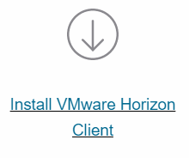

1. Locate the appropriate download





1. Click: **Go to Downloads** 
2. Click: **Download** 
3. Click or navigate to the **Downloaded file**: 
4. Click: **Agree and Install**
5. Click: **Finish**
6. Click**: Restart Now** 

***Using the App***

# Access My Virtual Desktop from home

1. Open **VMware Horizon**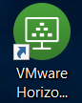
2. Click **Add Server** 
3. Type **desktopnc.niagaracollege.ca**

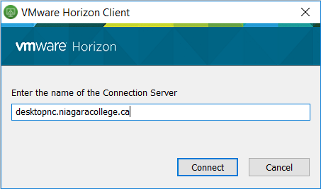

1. Login with**:**
   * **Blackboard Username**
   * **Blackboard Password**
2. Select: **desktopnc.niagaracollege.ca**
3. Login with**:**
   * **Blackboard Username**
   * **Blackboard Password**
4. Select the Desktop Shown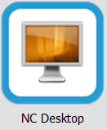
5. 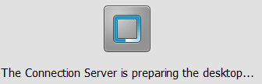  
   Be patient while it configures your settings
6. To Disconnect:

Click **Options** than **Disconnect and Log Off**

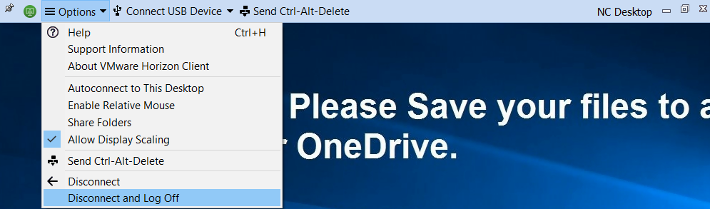

# ***From your Browser***

# Access My Virtual Desktop from home

1. Open your **Web browser** of Choice
2. Navigate to:[**https://desktopnc.niagaracollege.ca**](https://desktopnc.niagaracollege.ca)
3. Click**: VMware Horizon HTML Access**

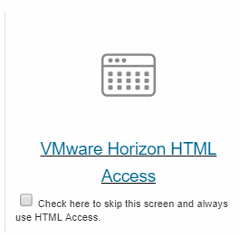

1. Fill in:
   * **Your Blackboard Username**
   * **Your Blackboard Password**
2. Click: **Login**