Stream Documentation

What is Microsoft Stream?
Microsoft Stream is an Enterprise Video service that is included with our existing licensing with Microsoft. It allows people in an organization to upload, view, organize and share videos securely.
Niagara College faculty, staff and students can access and use Microsoft Stream with their college network account.
Detailed documentation and how to videos provided by Microsoft: https://docs.microsoft.com/en-us/stream/

Access Microsoft Stream
Microsoft Stream can be accessed through several different URLs:
- Niagara College Portal – https://portalnc.niagaracollege.ca
  - (Under More Applications Microsoft O365 MS Stream)
- Microsoft Portal – https://portal.office.com
- Microsoft Stream Web Portal - https://web.microsoftstream.com/

- Login using your assigned email account
  - Faculty and Staff – username@niagaracollege.ca
  - Students – username@ncstudents.niagaracollege.ca
- Select Stream

Uploading Videos
Note: Please ensure you have acquired the necessary rights to play any licenced or copyrighted material. For guidance on College practices regarding copyright please visit https://nclibraries.niagaracollege.ca/copyright
- Select Create and Upload video
- Fill out the necessary details about your video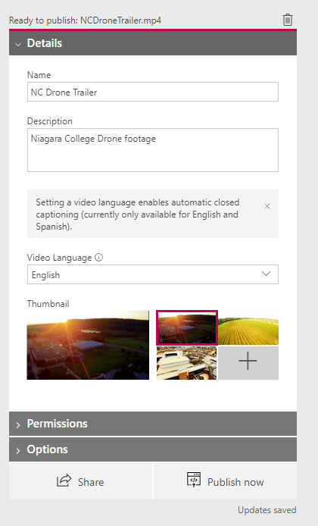

- Permissions
  - Allow everyone in your company to view this video box – When checked, anyone in the college can view this video – If you want to control access uncheck this box and assign the appropriate permissions under the “Shared with” section below - Example below – only two users will have access to this video
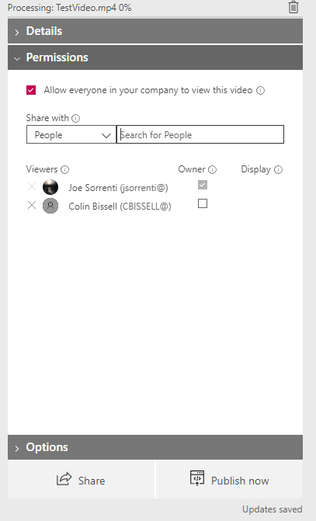

- Options
  - People - Generates a timeline of people in your video (using tagging)
  - Comments – Disabled at the administrative level
  - Captions – Captions are auto generated
  - Subtitles – You can upload subtitles to the video if available
- Share – You can copy the shareable URL from this tab and also customize the Embed options if you are looking to embed the video into another webpage or application
- Publish Now – This will conclude the video uploading process and make your video available

Removing Videos
- Select My Content located at the top of the screen, this will bring you to a list of videos you have published or started publishing (Drafts)

- Click the three dots located next to the video you want to delete and select Delete

Creating Channels
Note: Channels are a way to organize your content - They cannot be assigned permissions directly
Companywide channel - Anyone can add and watch these videos (Companywide channels may be created on your behalf by Niagara College Information Technology Services)
Group channel - Give access only to a specific group, like a department, team or class
- Select Create and Create a channel from the top navigation bar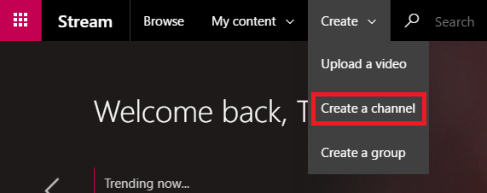

- In the Create a channel dialog, give a unique Channel name and Description for your channel – Channel names are limited to 30 characters – Channel descriptions are limited to 2,000 characters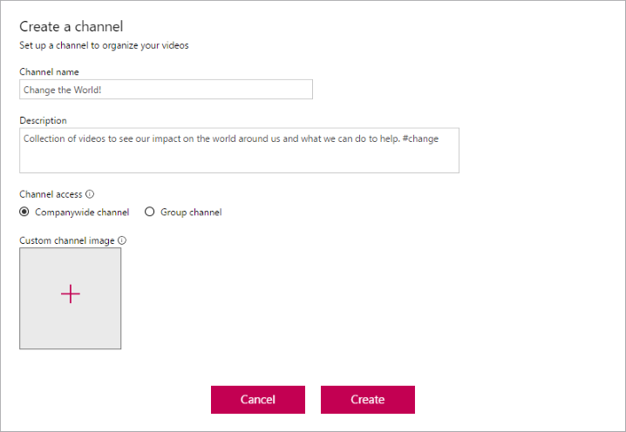

- For Channel access select if you want your channel to be a Companywide channel (companywide channels may be created on your behalf by Niagara College Information Technology Services) or a Group channel - If you select Group channel enter the group you want the channel to be contained in
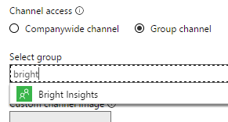

Note: You cannot change the channel type after the channel is created
- Add a Custom channel image to make your channel look unique
- Select Create
You can now start adding videos to your channel – You can also edit your channel's metadata or delete the channel

Creating Groups
- Select Create and Group from the top navigation bar.
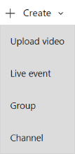
- In the Create a group dialog, give a Name and Description to your group
- In the Access drop down select if you want a Private group or Public group to determine who has access to the content inside your group
  - Public group means the group and videos/channels you add to it to be viewable by everyone in your organization
  - Private group means your group will be private and only the members of the group will be able to see the contents of the group
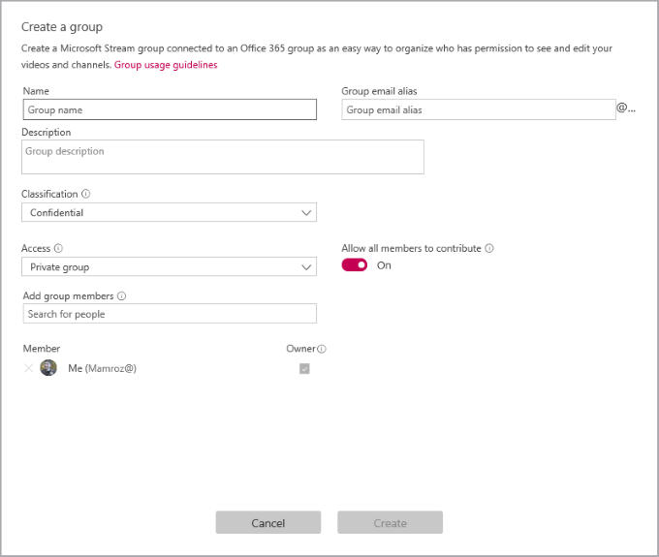
- Look up people in the Add group members field to include people in your group You can only add individual users to groups - If you would like a member to be an owner of the group check the box in the Owner column to upgrade their permission
- Turn Allow all members to contribute to On or Off to determine if the members of the group should be able to contribute to the group by adding/modify videos and channels or if they should just be viewers of the group only
Note: This setting only applies to Microsoft Stream, it does not apply to the O365 Group when used in the rest of Office 365
- Select Create.

Additional Resources and Information
Microsoft provides documentation and training videos on the Microsoft Stream product for free on their website. See https://docs.microsoft.com/en-us/stream/overview for more information on this product or contact the Niagara College ITS Service Desk.

